Weight Bias in Health Sciences

Calyope Ortega

2024-10-06

#Bivariate Correlations

options(repos = c(CRAN = "https://cloud.r-project.org/"))  
install.packages('Hmisc')

##   
## The downloaded binary packages are in  
## /var/folders/ty/r20j8lzs5_z9sg2jm9xkcrdc0000gn/T//Rtmp5PWrO8/downloaded_packages

library(Hmisc)

weight_ed.rcorr <- rcorr(as.matrix(weight_ed[,c("age","Duration","UMBFAT_SCALE","DIS_Subscale","NJ_Subscale","ER_Subscale",  
 "BAOP_SCALE","CURR_SCALE","CURR_HAES","CURR_WM","numsect")]))  
head(weight_ed.rcorr)

## $r  
## age Duration UMBFAT_SCALE DIS_Subscale NJ_Subscale  
## age 1.0000000000 -0.12430699 -0.10313934 -0.13101356 -0.03889626  
## Duration -0.1243069867 1.00000000 -0.08107983 -0.07834379 -0.06466014  
## UMBFAT_SCALE -0.1031393395 -0.08107983 1.00000000 0.84161909 0.78728336  
## DIS_Subscale -0.1310135616 -0.07834379 0.84161909 1.00000000 0.57926955  
## NJ_Subscale -0.0388962564 -0.06466014 0.78728336 0.57926955 1.00000000  
## ER_Subscale -0.0875554552 -0.06093638 0.85115520 0.56163080 0.45172566  
## BAOP_SCALE -0.0346390320 0.01766245 0.39263860 0.33971714 0.33095196  
## CURR_SCALE -0.0351662489 0.16550016 -0.39449865 -0.23139195 -0.36760758  
## CURR_HAES 0.0355332158 0.08837366 -0.38357967 -0.20732586 -0.35400562  
## CURR_WM 0.1343089755 -0.19501236 0.19008516 0.13982172 0.18148317  
## numsect 0.0002904383 -0.02673860 0.01169729 -0.01495372 -0.04140808  
## ER_Subscale BAOP_SCALE CURR_SCALE CURR_HAES CURR_WM  
## age -0.08755546 -0.03463903 -0.03516625 0.03553322 0.13430898  
## Duration -0.06093638 0.01766245 0.16550016 0.08837366 -0.19501236  
## UMBFAT_SCALE 0.85115520 0.39263860 -0.39449865 -0.38357967 0.19008516  
## DIS_Subscale 0.56163080 0.33971714 -0.23139195 -0.20732586 0.13982172  
## NJ_Subscale 0.45172566 0.33095196 -0.36760758 -0.35400562 0.18148317  
## ER_Subscale 1.00000000 0.31125936 -0.36793508 -0.37358720 0.15273082  
## BAOP_SCALE 0.31125936 1.00000000 -0.48273623 -0.33346076 0.44456233  
## CURR_SCALE -0.36793508 -0.48273623 1.00000000 0.87396661 -0.64458383  
## CURR_HAES -0.37358720 -0.33346076 0.87396661 1.00000000 -0.19285010  
## CURR_WM 0.15273082 0.44456233 -0.64458383 -0.19285010 1.00000000  
## numsect 0.06759578 -0.04282338 0.08902914 0.06453618 -0.07812938  
## numsect  
## age 0.0002904383  
## Duration -0.0267386018  
## UMBFAT_SCALE 0.0116972859  
## DIS_Subscale -0.0149537196  
## NJ_Subscale -0.0414080818  
## ER_Subscale 0.0675957809  
## BAOP_SCALE -0.0428233774  
## CURR_SCALE 0.0890291392  
## CURR_HAES 0.0645361798  
## CURR_WM -0.0781293758  
## numsect 1.0000000000  
##   
## $n  
## age Duration UMBFAT_SCALE DIS_Subscale NJ_Subscale ER_Subscale  
## age 120 120 120 120 120 120  
## Duration 120 122 122 122 122 122  
## UMBFAT_SCALE 120 122 122 122 122 122  
## DIS_Subscale 120 122 122 122 122 122  
## NJ_Subscale 120 122 122 122 122 122  
## ER_Subscale 120 122 122 122 122 122  
## BAOP_SCALE 120 122 122 122 122 122  
## CURR_SCALE 120 122 122 122 122 122  
## CURR_HAES 120 122 122 122 122 122  
## CURR_WM 120 122 122 122 122 122  
## numsect 120 121 121 121 121 121  
## BAOP_SCALE CURR_SCALE CURR_HAES CURR_WM numsect  
## age 120 120 120 120 120  
## Duration 122 122 122 122 121  
## UMBFAT_SCALE 122 122 122 122 121  
## DIS_Subscale 122 122 122 122 121  
## NJ_Subscale 122 122 122 122 121  
## ER_Subscale 122 122 122 122 121  
## BAOP_SCALE 122 122 122 122 121  
## CURR_SCALE 122 122 122 122 121  
## CURR_HAES 122 122 122 122 121  
## CURR_WM 122 122 122 122 121  
## numsect 121 121 121 121 121  
##   
## $P  
## age Duration UMBFAT_SCALE DIS_Subscale NJ_Subscale  
## age NA 0.17614676 2.622872e-01 1.537773e-01 6.731805e-01  
## Duration 0.1761468 NA 3.746486e-01 3.910324e-01 4.792041e-01  
## UMBFAT_SCALE 0.2622872 0.37464860 NA 0.000000e+00 0.000000e+00  
## DIS_Subscale 0.1537773 0.39103241 0.000000e+00 NA 2.750244e-12  
## NJ_Subscale 0.6731805 0.47920412 0.000000e+00 2.750244e-12 NA  
## ER_Subscale 0.3416498 0.50492838 0.000000e+00 1.696998e-11 1.764347e-07  
## BAOP_SCALE 0.7072198 0.84688465 7.706427e-06 1.291016e-04 1.966030e-04  
## CURR_SCALE 0.7029712 0.06848912 6.915711e-06 1.033547e-02 3.108479e-05  
## CURR_HAES 0.7000193 0.33306143 1.293626e-05 2.194197e-02 6.328909e-05  
## CURR_WM 0.1435997 0.03135653 3.598425e-02 1.245289e-01 4.544021e-02  
## numsect 0.9974880 0.77095674 8.986722e-01 8.706817e-01 6.520224e-01  
## ER_Subscale BAOP_SCALE CURR_SCALE CURR_HAES CURR_WM  
## age 3.416498e-01 7.072198e-01 7.029712e-01 7.000193e-01 1.435997e-01  
## Duration 5.049284e-01 8.468846e-01 6.848912e-02 3.330614e-01 3.135653e-02  
## UMBFAT_SCALE 0.000000e+00 7.706427e-06 6.915711e-06 1.293626e-05 3.598425e-02  
## DIS_Subscale 1.696998e-11 1.291016e-04 1.033547e-02 2.194197e-02 1.245289e-01  
## NJ_Subscale 1.764347e-07 1.966030e-04 3.108479e-05 6.328909e-05 4.544021e-02  
## ER_Subscale NA 4.835940e-04 3.054503e-05 2.250826e-05 9.306071e-02  
## BAOP_SCALE 4.835940e-04 NA 1.791706e-08 1.745276e-04 2.899895e-07  
## CURR_SCALE 3.054503e-05 1.791706e-08 NA 0.000000e+00 1.110223e-15  
## CURR_HAES 2.250826e-05 1.745276e-04 0.000000e+00 NA 3.332126e-02  
## CURR_WM 9.306071e-02 2.899895e-07 1.110223e-15 3.332126e-02 NA  
## numsect 4.613178e-01 6.409424e-01 3.315059e-01 4.818920e-01 3.943221e-01  
## numsect  
## age 0.9974880  
## Duration 0.7709567  
## UMBFAT_SCALE 0.8986722  
## DIS_Subscale 0.8706817  
## NJ_Subscale 0.6520224  
## ER_Subscale 0.4613178  
## BAOP_SCALE 0.6409424  
## CURR_SCALE 0.3315059  
## CURR_HAES 0.4818920  
## CURR_WM 0.3943221  
## numsect NA

#Data Visualizations

#boxplot  
boxplot(weight_ed$CURR_HAES, na.rm = TRUE, col = '#85acef', cex.lab = 1.8, main = 'Health At Every Size', ylab = 'HAES Score (1-6)', cex.main = 2)

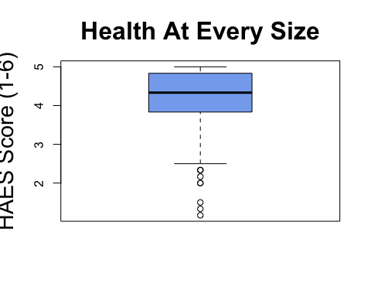

boxplot(weight_ed$CURR_WM, na.rm = TRUE, col = '#a0aec6',cex.lab = 1.8, main = 'Weight Management', ylab = 'WM Score (1-6)', cex.main = 2)

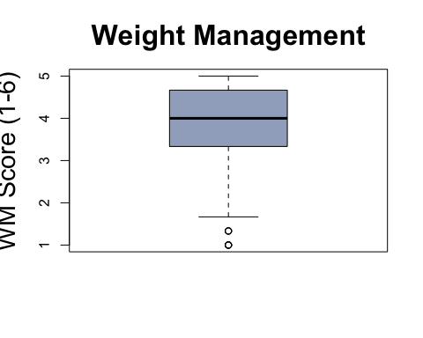

#adding the mean abline(h = mean)  
  
par("mar")

## [1] 5.1 4.1 4.1 2.1

par(mar=c(5.1, 5.1, 4.1, 2.1))  
library(ggplot2)  
  
#violin plot (to understand the density)  
  
library('vioplot')

install.packages('vioplot')

##   
## The downloaded binary packages are in  
## /var/folders/ty/r20j8lzs5_z9sg2jm9xkcrdc0000gn/T//Rtmp5PWrO8/downloaded_packages

vioplot(weight_ed$CURR_HAES, na.rm = TRUE, col = 'skyblue2', main = 'Curriculum Health At Every Size', ylab = 'CURR_HAES Score (1-6)', names = '')

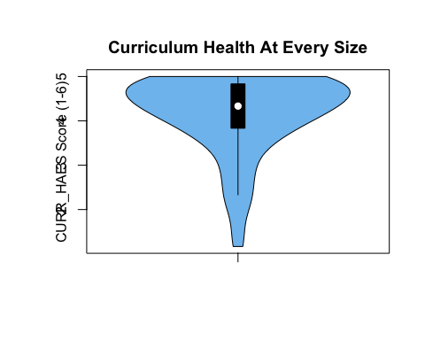

vioplot(weight_ed$CURR_WM, na.rm = TRUE, col = 'skyblue', main = 'Curriculum Weight Management', ylab = 'CURR_WM Score (1-6)', names = '')

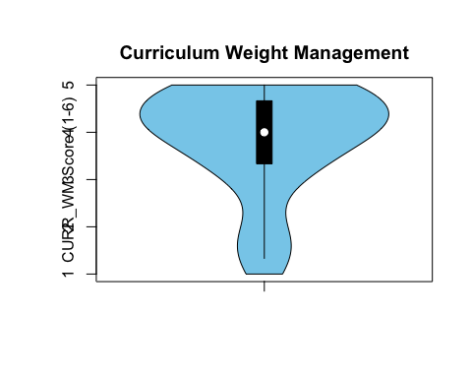

#scatterplots  
  
plot(weight_ed$CURR_HAES,weight_ed$UMBFAT_SCALE, col = '#85acef',cex.lab = 1.8, pch = 16, xlab = 'HAES (1-6)', ylab = 'Weight Prejudice (1-7)', main = 'Relationship between HAES & Prejudice', cex.main = 2, cex = 1.5)

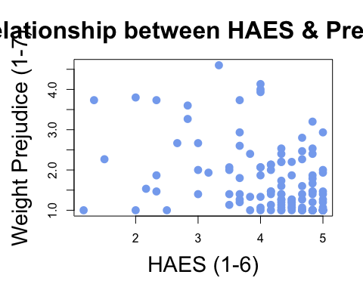

plot(weight_ed$CURR_HAES,weight_ed$BAOP_SCALE, col = '#85acef',cex.lab = 1.8, pch = 16, xlab = 'HAES (1-6)', ylab = 'Weight Stereotypes (1-6)', main = 'Relationship between HAES & Stereotypes',cex.main = 2, cex = 1.5)

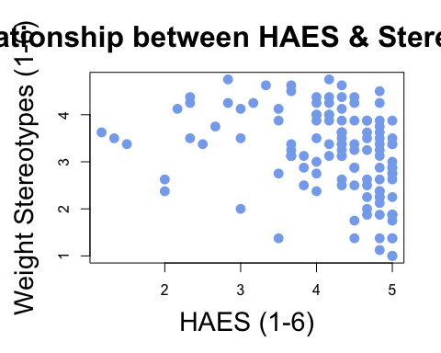

plot(weight_ed$CURR_WM,weight_ed$UMBFAT_SCALE, col = '#a0aec6',cex.lab = 1.8, pch = 16, xlab = 'WM (1-6)', ylab = 'Weight Prejudice (1-7)', main = 'Relationship between WM & Prejudice', cex.main = 2, cex = 1.5)

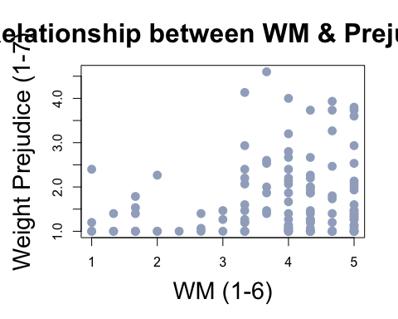

plot(weight_ed$CURR_WM,weight_ed$BAOP_SCALE, col = '#a0aec6', cex.lab =1.8, pch = 16, xlab = 'CURR WM (1-6)', ylab = 'Weight Stereotypes SCALE (1-6)', main = 'Relationship between WM & Stereotypes',cex.main = 2, cex = 1.5)

